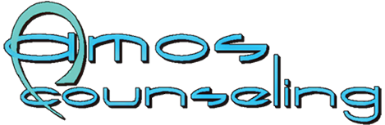
Paid Internship for CAT and CAS
Amos Counseling provides paid internships to help support your 1000 hours for CAT.
$20.00 per hour for this position
You will learn.
- Orientation
- Service Coordination
- Administration intake
- Administration Discharge
- Discharge Planning
- Record Keeping
- Behavioral health education and prevention
- Co-Facilitation of Counseling session.
Paid internship will be provided for all CAS hours, with successful completion of the CAT. This position will be paid at $25.00 per hour of work.
You will learn.
- Clinical Screening and evaluations/assessments
- Clinical discharge/discharge planning
- Clinical Treatment planning
- Counseling for Individuals, Group and /or Families
- Brief Psychotherapy
- DUI Level I and II Education
- DUI Level II Therapy
- Other client interactions (see CAT service Hours for guidance)
Both will be full-time positions that also offer Medical/Dental and paid sick time. This will entail some nights and weekend work to support the Substance Abuse groups that are run during the evening.

1131 N. 21St Street Phone: 970-778-4360
Grand Junction, CO 81501 Fax: 970-241-2282
Mesa County Email: amoscounseling@yahoo.com
Website: http://amoscounseling.com

